Written Instructions Draft:

In the last activity you learned differences between short and long burst GRB. In today’s activities, you are going to look at different properties of a mystery GRB spotted by Fermi’s Gamma-ray Space Telescope.

**Step 1:**

To start, here are a few GRB’s which were detected by Fermi’s Gamma Ray Telescope. On each spreadsheet there are the raw flux counts detected by the detectors on the telescope during a brief period of time when a GRB signal was detected. Your first task is to determine the T90 of each of these three bursts.

T90 is the time period of the burst where 90% (photon flux accumulation over time between 5% and 95% of the fluence) of the total light counts from the burst were detected. To calculate this amount of time, you will first need to determine when each burst begins, and ends. Take a look at the table and see where the counts begin to sharply rise (this will be near when time=0, but it will not be exactly at 0, possibly a few points before or after). Mark where this increase begins, and mark where the counts return to what they were before the jump/burst

Now, in this time period, you will need to sum up the total amount of flux detected. To get T90, we need the flux within our time to equal 90% of this total flux detection value. One way to do this, is add up the total flux counts during the burst (period where the counts are higher). Then calculate what 5% of this total flux is. Now see at what time (after the beginning of the burst) where the total flux has added up to 5% of your original total, then mark that time. Now go to the end of the burst and see at what time **before the end,** 5% of your burst occurs. Calculate the length of time between these two points…This is your T90!

Now of these three bursts, one is clearly a short burst, one is clearly a long burst. But what about the third? This third we are going to call our ‘Mystery Burst’. It is the very special GRB that we will investigate further.

**Step 2:**

Now that we have the T90 of our mystery burst, we are going to try to approximate the direction it came from. To do this, first look at the graphic below. This represents each detector on the Fermi GRST, and the direction it ‘looks’. As you can see, each detector has a rough range of RA and Dec at which it **best** detects signals. It is important to note that these detectors have a much greater range than the colored-in sections of this graphic. These regions are simply the regions at which the incoming signals are highly incident to the detectors.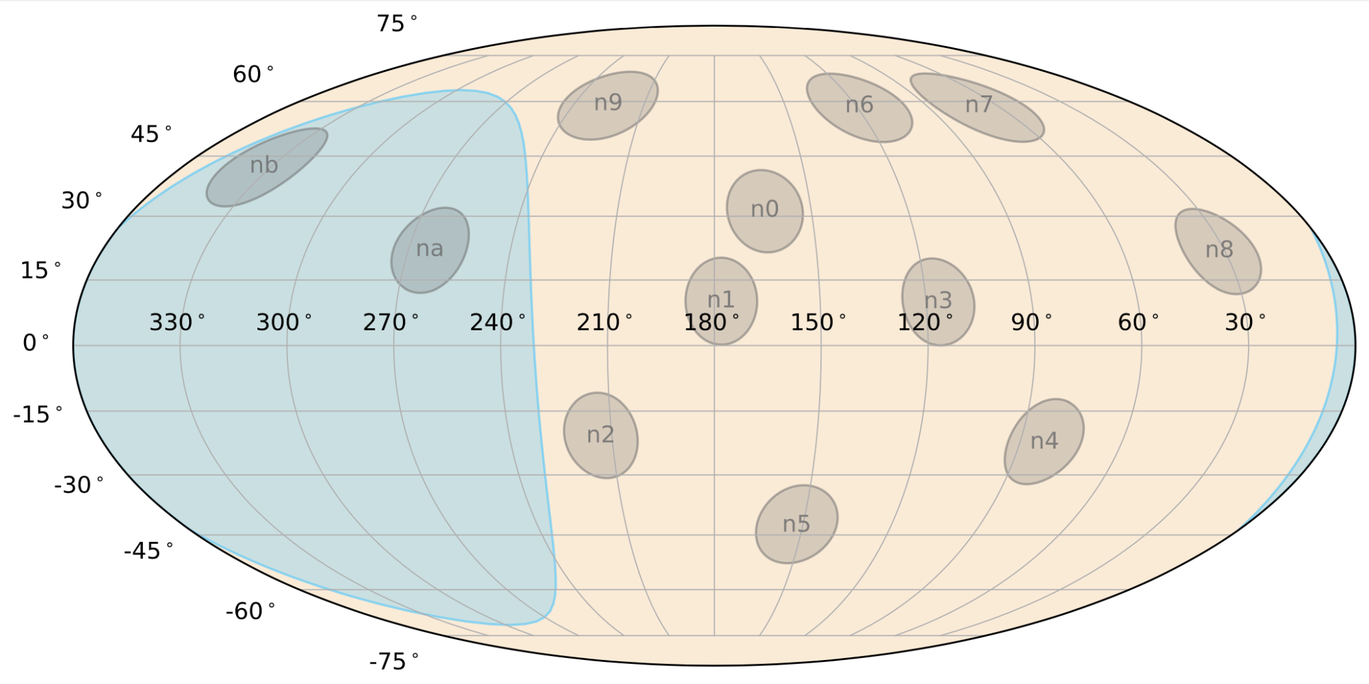

Now, let’s look at the light curves of each of the detectors during the time of the mystery event. See if you can pick out which detectors had the strongest signals/highest light counts (Hint: you should find 3 have noticeably more than the others). What do you think that means? It means the signal from this mystery burst likely originated in a direction where each of these detectors can best detect. Select the squares that are closest to all three detectors? Grid square instr…

**Step 3:**

When we look at the total flux given off of this GRB, while considering the distance at which it came from (given by the Gravitational Waves Team), we notice it seems very weak for what we expect. We know there must be another factor at play. This factor is called the angle of inclination. The angle of inclination can be thought of as simply the angle between the vector of the burst and us (more specifically the detectors). If the burst is not pointing directly at the detectors, the detectors will pick up only a portion of the actual flux values.

In this step we want to try to estimate at which angle the burst is pointing at us. To do so, put in the approximate distance that the grav waves team gave you. Now slide the ‘Inclination Bar’. This bar represents increasing (and decreasing) the angle at which the mystery GRB is pointing at us. Slide it until the affected flux lines up with what we actually observed. What angle does that yield? Is there some range where it could lie between?